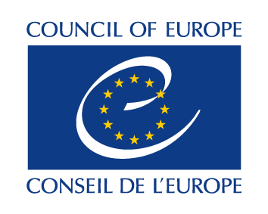
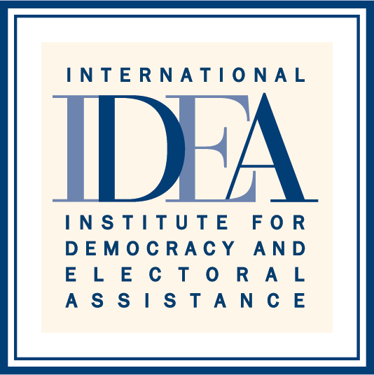

SIXTH HIGH LEVEL MEETING OF THE INTER-REGIONAL DIALOGUE ON DEMOCRACY
8 November 2016 - Strasbourg, France
Palais de L’Europe – Room 13

AGENDA

- Opening Remarks by H.E. Thorbjørn Jagland, Secretary General of the Council of Europe (5-10 mins)

- Welcoming Remarks by H.E. Yves Leterme, Secretary General of International IDEA (5-10 mins)

- Keynote address by Mr. Michael Møller, Director-General of the United Nations Office in Geneva, representing Secretary-General Ban Ki-moon (15 mins)

- Promoting Gender Equality and Political Empowerment of Women

In recognition of the work advanced by the Regional Organizations on gender equality and political empowerment of women as a key element to strengthen democracy in the regions, and its link to education to tackle the main challenges in this field, the Sixth High Level Meeting of the Inter-Regional Dialogue on Democracy adopts the theme: “Education for Democracy as a Central Element for the Promotion of Gender Equality and the Empowerment of Women”.

In particular, the Sixth High Level Meeting will endeavour to follow these guiding questions:

- What are the experiences and lessons learned by your regional organization regarding gender equality and political empowerment of women? How does these lessons incorporate regional policies on Education?

- What activities can regional organizations jointly undertake, and in cooperation with the UN and the Communities of Democracies, to enhance gender equality and political empowerment of women?

- What concrete measures are needed to strengthen the effectiveness of the work of regional organizations in promoting gender equality?

- How can regional organizations make use of information and communication technologies, such as the internet and social media to strengthen their democracy support work and improve their outreach, especially to the youth?

- Briefing on the Policy Roundtable organized by the Council of Europe, with the Heads of the Regional Organizations.
- Next stages of the Inter-Regional Dialogue for Democracy (IRDD)

- Date and Venue of a possible Seventh High Level Meeting of the Inter-Regional Dialogue on Democracy

- Other Matters

