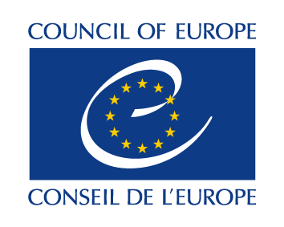 | 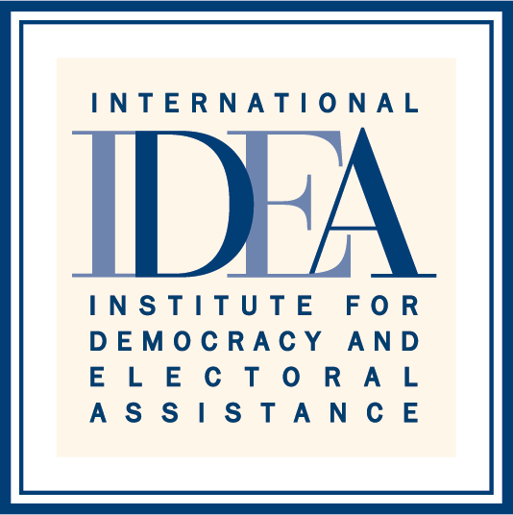

SIXTH HIGH LEVEL MEETING
OF THE INTER-REGIONAL DIALOGUE ON DEMOCRACY
7-9 November 2016
Council of Europe, Strasbourg, France

PROGRAMME OF ACTIVITES

7 November
All day  8 November  9:00 - 9:30 | Arrival of Heads of the Regional Organizations and Senior Officials  Arrival and Registration of the Senior Officials
9:30 - 12:30 | Senior Officials Meeting
12:30 - 14:00 | Lunch for the Heads of the Regional Organizations and the Senior Officials, hosted by the Secretary General of the Council of Europe – Venue: Le Salon Blue at the Council of Europe - Palais de l’Europe
14:00 - 16:30 | Sixth High Level Meeting of the Inter-Regional Dialogue on Democracy
16:30 -17:00 | Press Conference
19:30 - 22:00  9 November | Welcome Dinner hosted by the Secretary General of International IDEA – Venue: Restaurant Zimmer
9:00 -10:00 | Policy Roundtable “Regional Outlook on the Implementation of Agenda 2030 for Sustainable Development” – Jointly organized by the Council of Europe and International IDEA
10:00-12:30 | Closing Session – World Forum for Democracy 2016
12:30 - | Departure of Heads of the Regional Organizations and Senior Officials

