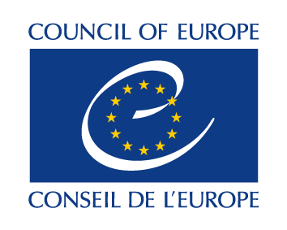
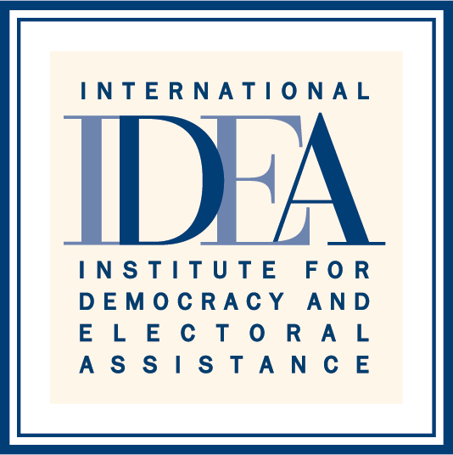
SIXTH HIGH LEVEL MEETING
INTER-REGIONAL DIALOGUE ON DEMOCRACY (IRDD)
8 November 2016
Council of Europe – Strasbourg, France

LIST OF PARTICIPANTS

Community of Democracies (CoD)
Maria Leissner Secretary-General

Council of Europe (CoE)
Thorbjørn Jagland Secretary-General
Zoltán Taubner Director for External Relations
Jiri Vogl Head, Department of Relations with International Organisations and non-member States
Max Gilbert Adviser, Directorate of External Relations
Hallvard Gorseth Adviser, Office of the Secretary General

European Commission (EC)
Jean-Louis Ville Director for Human Development and Migration

Organization of American States (OAS)
Nestor Mendez Assistant Secretary General
Yadira Soto Senior Advisor, Office of the Assistant Secretary-General

Pacific Islands Forum (PIF)
Andie Fong Toy Deputy Secretary-General
Angela Thomas Human Security Officer, Political Governance and Security Programme

South Asian Association for Regional Cooperation (SAARC)
Maihan Saeedi Director

United Nations
Michael Møller Director-General of the United Nations Office at Geneva

International IDEA
Yves Leterme Secretary-General
Karin Gardes Director, External Relations and Governance Support
Andrew Bradley Director, International IDEA Office in Brussels
Luis Consuegra Programme Officer, External Relations and Governance Support
Katarina Jörgensen Officer, Communications and Knowledge Management

