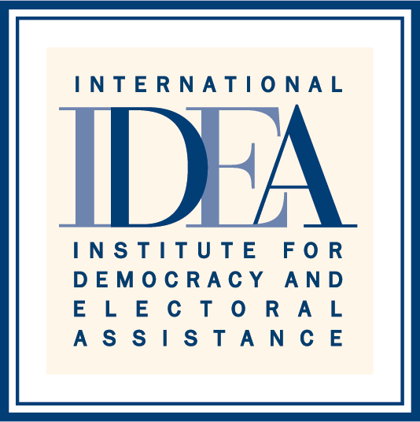
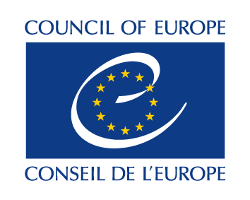
SIXTH HIGH LEVEL MEETING OF THE
INTER-REGIONAL DIALOGUE ON DEMOCRACY
8 November 2016 9:30-12.30
Palais de L’Europe – Room 13

AGENDA
SENIOR OFFICIALS MEETING

- Opening remarks by Zoltan Taubner, Director for External Relations, Council of Europe

- Welcoming remarks by Karin Gardes, Director for External Relations and Governance Support, International IDEA.

- Sixth High Level Meeting of the Inter-Regional Dialogue on Democracy

- Programme of Activities
- Agenda of the Sixth High Level Meeting
- Press Conference

- Policy Roundtable “Outlook on the Regional Perspectives for the Implementation of Agenda 2030 for Sustainable Development”.

A. Concept Note
B. Programme

- Presentation of the IRDD Policy Guidebook on Gender Equality and Political Participation of Women by International IDEA

- Exchange on the current situation of the IRDD, and brainstorming on how to make the platform financially sustainable.

- Exchange of views on a possible 2017 work plan for the IRDD

- Exchange of views on a possible Seventh High Level Meeting of the Inter-Regional Dialogue on Democracy

- Other matters

